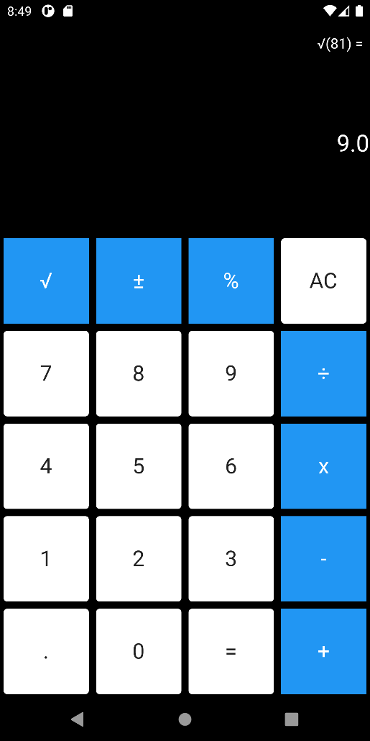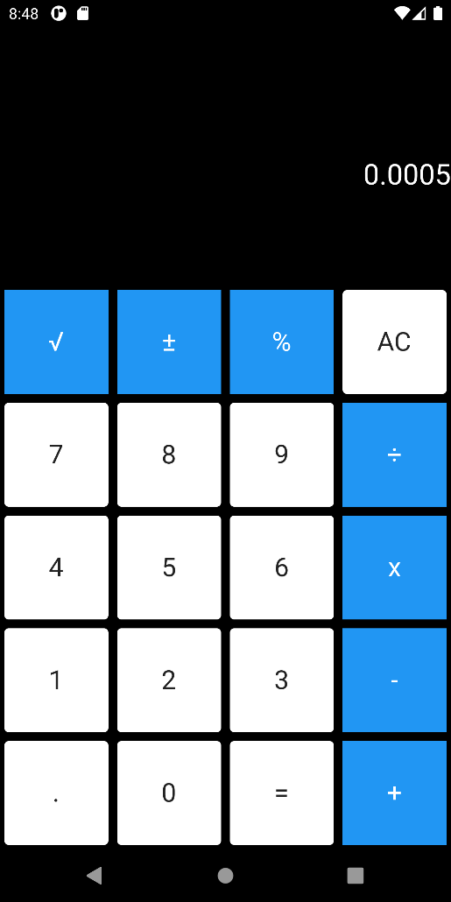

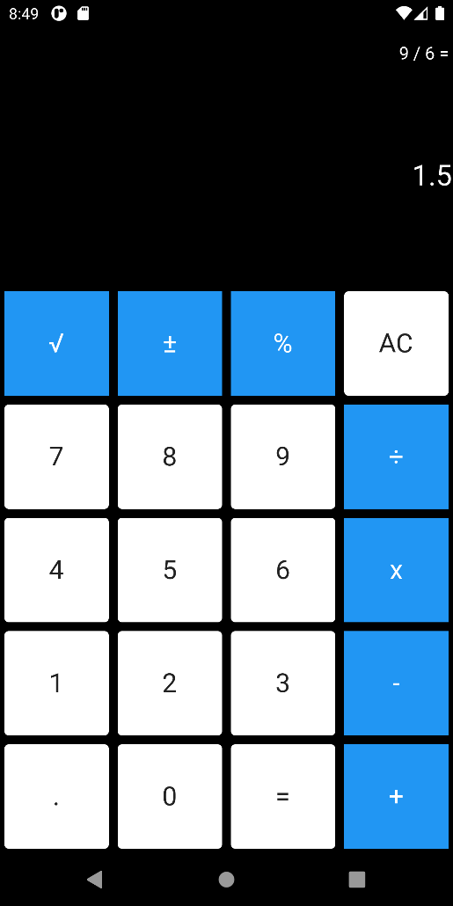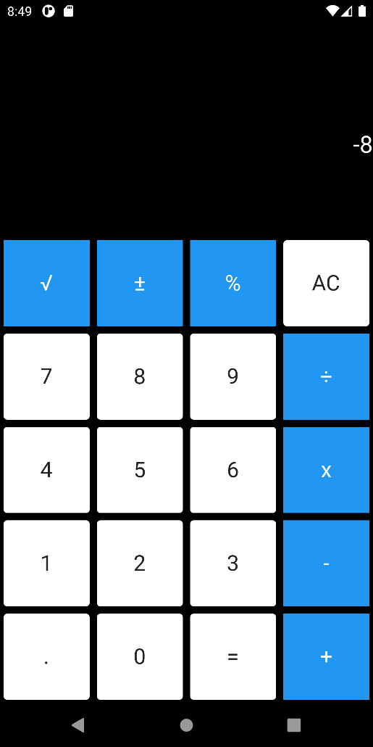

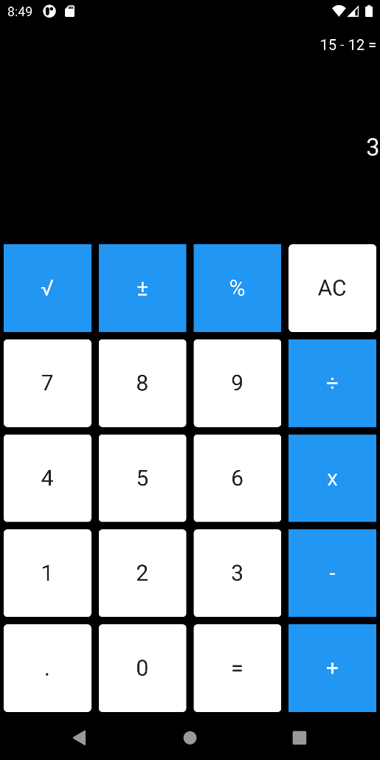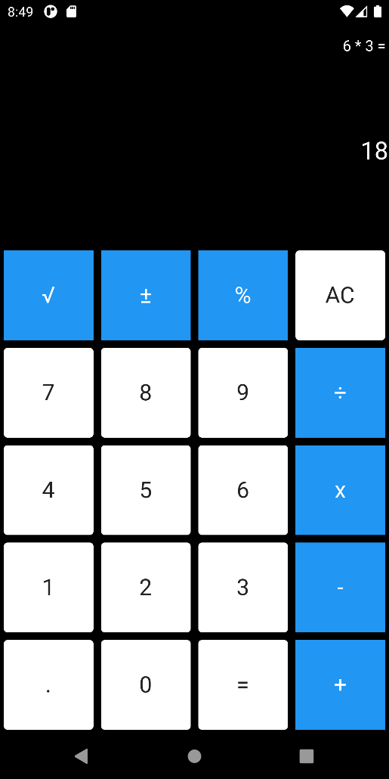

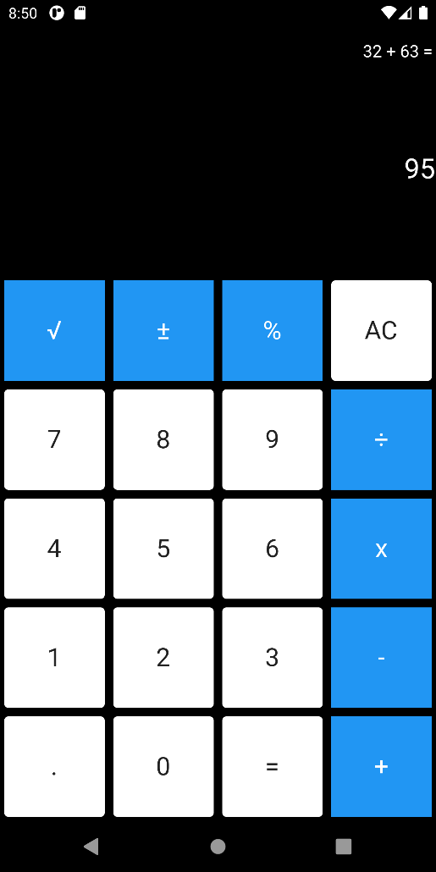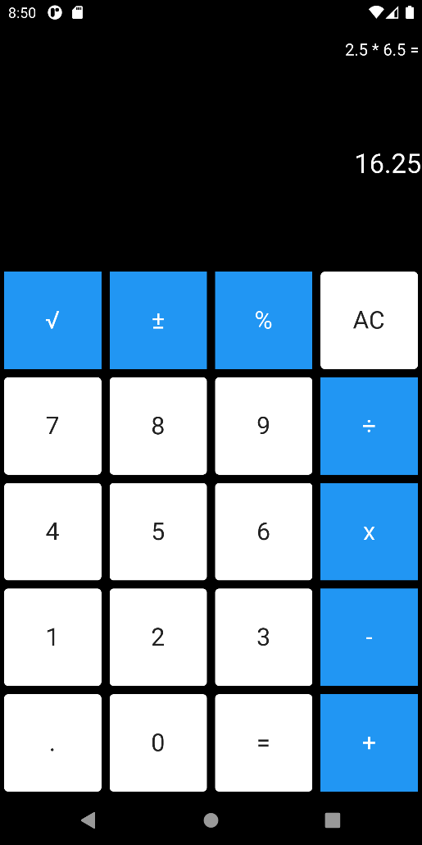

# Code

import 'dart:math';  
import 'package:expression_language/expression_language.dart';  
  
import 'package:flutter/material.dart';  
  
void main() {  
 runApp(MyApp());  
}  
  
class MyApp extends StatefulWidget {  
 @override  
 _MyAppState createState() => _MyAppState();  
}  
  
class _MyAppState extends State<MyApp> {  
 String calculation;  
 String result;  
  
 @override  
 void initState() {  
 super.initState();  
 calculation = "";  
 result = "0";  
 }  
  
 @override  
 Widget build(BuildContext context) {  
 return MaterialApp(  
 debugShowCheckedModeBanner: false,  
 theme: ThemeData(  
 primaryColor: Colors.*white*,  
 accentColor: Colors.*orange* ),  
 home: Scaffold(  
 backgroundColor: Colors.*black*,  
 body: SafeArea(  
 child: Column(  
 mainAxisAlignment: MainAxisAlignment.spaceBetween,  
 mainAxisSize: MainAxisSize.max,  
 crossAxisAlignment: CrossAxisAlignment.end,  
 children: [  
 Padding(  
 padding: EdgeInsets.only(top: 15, right: 3),  
 child: Text(calculation, style: TextStyle(color: Colors.*white*, fontSize: 16),),  
 ),  
 Text(result, style: TextStyle(color: Colors.*white*, fontSize: 26),),  
 GridView.count(  
 primary: false,  
 crossAxisCount: 4,  
 padding: EdgeInsets.*zero*,  
 shrinkWrap: true,  
 crossAxisSpacing: 0,  
 mainAxisSpacing: 0,  
 children: [  
 GestureDetector(  
 onTap: (){setState(() {  
 try{  
 calculation = "√($result) = ";  
 result = sqrt(double.*parse*(result)).toString();  
 }  
 catch(e){  
 result = "err";  
 }  
 });  
 },  
 child: Card(  
 elevation: 0.3,  
 child: Container(  
 color: Theme.*of*(context).accentColor,  
 child: Center(  
 child: Text("√", style: TextStyle(fontSize: 24, color: Colors.*white*)),  
 ),  
 ),  
 ),  
 ),  
 GestureDetector(  
 onTap: (){setState(() {  
 try{  
 if (result != "0") {  
 if (result[0] != '-')  
 result = "-" + result;  
 else  
 result = result.substring(1);  
 }  
 }  
 catch(e){  
 print(e.toString());  
 result = "err";  
 }  
 });  
 },  
 child: Card(  
 elevation: 0.3,  
 child: Container(  
 color: Theme.*of*(context).accentColor,  
 child: Center(  
 child: Text("±", style: TextStyle(fontSize: 24, color: Colors.*white*)),  
 ),  
 ),  
 ),  
 ),  
 GestureDetector(  
 onTap: (){setState(() {  
 try{  
 result = (double.*parse*(result) / 100).toString();  
 }  
 catch(e){  
 result = "err";  
 }  
 });  
 },  
 child: Card(  
 elevation: 0.3,  
 child: Container(  
 color: Theme.*of*(context).accentColor,  
 child: Center(  
 child: Text("%", style: TextStyle(fontSize: 24, color: Colors.*white*)),  
 ),  
 ),  
 ),  
 ),  
 GestureDetector(  
 onTap: (){setState(() {  
 try{  
 calculation = "";  
 result = "0";  
 }  
 catch(e){  
 result = "err";  
 }  
 });},  
 child: Card(  
 elevation: 0.3,  
 child: Container(  
 child: Center(  
 child: Text("AC", style: TextStyle(fontSize: 24)),  
 ),  
 ),  
 ),  
 ),  
 GestureDetector(  
 onTap: (){setState(() {  
 try{  
 if (result == "0")  
 result = "";  
 result = result + "7";  
 }  
 catch(e){  
 result = "err";  
 }  
 });},  
 child: Card(  
 elevation: 0.3,  
 child: Container(  
 child: Center(  
 child: Text("7", style: TextStyle(fontSize: 24)),  
 ),  
 ),  
 ),  
 ),  
 GestureDetector(  
 onTap: (){setState(() {  
 try{  
 if (result == "0")  
 result = "";  
 result = result + "8";  
 }  
 catch(e){  
 result = "err";  
 }  
 });},  
 child: Card(  
 elevation: 0.3,  
 child: Container(  
 child: Center(  
 child: Text("8", style: TextStyle(fontSize: 24)),  
 ),  
 ),  
 ),  
 ),  
 GestureDetector(  
 onTap: (){setState(() {  
 try{  
 if (result == "0")  
 result = "";  
 result = result + "9";  
 }  
 catch(e){  
 result = "err";  
 }  
 });},  
 child: Card(  
 elevation: 0.3,  
 child: Container(  
 child: Center(  
 child: Text("9", style: TextStyle(fontSize: 24)),  
 ),  
 ),  
 ),  
 ),  
 GestureDetector(  
 onTap: (){setState(() {  
 try{  
 if (result != "0"){  
 if (calculation == "") {  
 calculation = result + " / ";  
 result = "0";  
 }  
 }  
 }  
 catch(e){  
 print(e);  
 result = "err";  
 }  
 });},  
 child: Card(  
 elevation: 0.3,  
 child: Container(  
 color: Theme.*of*(context).accentColor,  
 child: Center(  
 child: Text("÷", style: TextStyle(fontSize: 24, color: Colors.*white*)),  
 ),  
 ),  
 ),  
 ),  
 GestureDetector(  
 onTap: (){setState(() {  
 try{  
 if (result == "0")  
 result = "";  
 result = result + "4";  
 }  
 catch(e){  
 result = "err";  
 }  
 });},  
 child: Card(  
 elevation: 0.3,  
 child: Container(  
 child: Center(  
 child: Text("4", style: TextStyle(fontSize: 24)),  
 ),  
 ),  
 ),  
 ),  
 GestureDetector(  
 onTap: (){setState(() {  
 try{  
 if (result == "0")  
 result = "";  
 result = result + "5";  
 }  
 catch(e){  
 result = "err";  
 }  
 });},  
 child: Card(  
 elevation: 0.3,  
 child: Container(  
 child: Center(  
 child: Text("5", style: TextStyle(fontSize: 24)),  
 ),  
 ),  
 ),  
 ),  
 GestureDetector(  
 onTap: (){setState(() {  
 try{  
 if (result == "0")  
 result = "";  
 result = result + "6";  
 }  
 catch(e){  
 result = "err";  
 }  
 });},  
 child: Card(  
 elevation: 0.3,  
 child: Container(  
 child: Center(  
 child: Text("6", style: TextStyle(fontSize: 24)),  
 ),  
 ),  
 ),  
 ),  
 GestureDetector(  
 onTap: (){setState(() {  
 try{  
 if (result != "0"){  
 if (calculation == "") {  
 calculation = result + " * ";  
 result = "0";  
 }  
 }  
 }  
 catch(e){  
 result = "err";  
 }  
 });},  
 child: Card(  
 elevation: 0.3,  
 child: Container(  
 color: Theme.*of*(context).accentColor,  
 child: Center(  
 child: Text("x", style: TextStyle(fontSize: 24, color: Colors.*white*)),  
 ),  
 ),  
 ),  
 ),  
 GestureDetector(  
 onTap: (){setState(() {  
 try{  
 if (result == "0")  
 result = "";  
 result = result + "1";  
 }  
 catch(e){  
 result = "err";  
 }  
 });},  
 child: Card(  
 elevation: 0.3,  
 child: Container(  
 child: Center(  
 child: Text("1", style: TextStyle(fontSize: 24)),  
 ),  
 ),  
 ),  
 ),  
 GestureDetector(  
 onTap: (){setState(() {  
 try{  
 if (result == "0")  
 result = "";  
 result = result + "2";  
 }  
 catch(e){  
 result = "err";  
 }  
 });},  
 child: Card(  
 elevation: 0.3,  
 child: Container(  
 child: Center(  
 child: Text("2", style: TextStyle(fontSize: 24)),  
 ),  
 ),  
 ),  
 ),  
 GestureDetector(  
 onTap: (){setState(() {  
 try{  
 if (result == "0")  
 result = "";  
 result = result + "3";  
 }  
 catch(e){  
 result = "err";  
 }  
 });},  
 child: Card(  
 elevation: 0.3,  
 child: Container(  
 child: Center(  
 child: Text("3", style: TextStyle(fontSize: 24)),  
 ),  
 ),  
 ),  
 ),  
 GestureDetector(  
 onTap: (){setState(() {  
 try{  
 if (result != "0"){  
 if (calculation == "") {  
 calculation = result + " - ";  
 result = "0";  
 }  
 }  
 }  
 catch(e){  
 result = "err";  
 }  
 });},  
 child: Card(  
 elevation: 0.3,  
 child: Container(  
 color: Theme.*of*(context).accentColor,  
 child: Center(  
 child: Text("-", style: TextStyle(fontSize: 24, color: Colors.*white*)),  
 ),  
 ),  
 ),  
 ),  
 GestureDetector(  
 onTap: (){setState(() {  
 try{  
 result = result + ".";  
 }  
 catch(e){  
 result = "err";  
 }  
 });},  
 child: Card(  
 elevation: 0.3,  
 child: Container(  
 child: Center(  
 child: Text(".", style: TextStyle(fontSize: 24)),  
 ),  
 ),  
 ),  
 ),  
 GestureDetector(  
 onTap: (){setState(() {  
 try{  
 if (result != "0")  
 result = result + "0";  
 }  
 catch(e){  
 result = "err";  
 }  
 });},  
 child: Card(  
 elevation: 0.3,  
 child: Container(  
 child: Center(  
 child: Text("0", style: TextStyle(fontSize: 24)),  
 ),  
 ),  
 ),  
 ),  
 GestureDetector(  
 onTap: (){setState(() {  
 try{  
 if (calculation.contains("+") || calculation.contains("-") || calculation.contains("/") || calculation.contains(" * ")){  
 calculation = calculation + result;  
  
 var expressionGrammarDefinition = ExpressionGrammarParser({});  
 var parser = expressionGrammarDefinition.build();  
 var expression = parser.parse(calculation).value as Expression;  
  
 calculation += " =";  
  
 result = expression.evaluate().toString();  
 }  
 }  
 catch(e){  
 print(e);  
 result = "err";  
 }  
 });},  
 child: Card(  
 elevation: 0.3,  
 child: Container(  
 child: Center(  
 child: Text("=", style: TextStyle(fontSize: 24)),  
 ),  
 ),  
 ),  
 ),  
 GestureDetector(  
 onTap: (){setState(() {  
 try{  
 if (result != "0"){  
 if (calculation == "") {  
 calculation = result + " + ";  
 result = "0";  
 }  
 }  
 }  
 catch(e){  
 result = "err";  
 }  
 });},  
 child: Card(  
 elevation: 0.3,  
 child: Container(  
 color: Theme.*of*(context).accentColor,  
 child: Center(  
 child: Text("+", style: TextStyle(fontSize: 24, color: Colors.*white*)),  
 ),  
 ),  
 ),  
 ),  
 ],  
 )  
 ],  
 ),  
 ),  
 )  
 );  
 }  
}